Tech Tip #1:
As you may or may not know we have some ready-made email groups for you to use. I wanted to make sure you know who actually receives these emails…

Ritt_staff – This goes to everyone that works for Rittman Schools
Ritt_teacher – This goes to all teaching and admin staff
Ritt_hs – All HS staff, all admin (including Central Office), certified and classified
Ritt_ms – All MS staff, all admin (including Central Office), certified and classified
Ritt_res - All RES staff, all admin (including Central Office), certified and classified

When you use one of these you are able to remove folks manually if you don’t think that the email would pertain to them.

- Create your new email and address it to one of the above groups.
- Click the plus sign next to the group name in the “To” box. Outlook will give you a warning message. You may say OK to this. You can also check the box so it doesn’t give you the warning again.
- Once you have clicked the plus sign, the list expands to show you all folks that it is sending to. You can highlight, right click, and cut those staff members that don’t need to receive the email.
- Don’t worry as this only effects the email you are working on. It does not alter the original group list.

Tech Tip #2
You can also create your own groups for folks to whom you routinely send email, for example – your grade level team, committee members etc.
  - See the following page for instructions on creating your own groups.

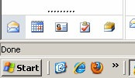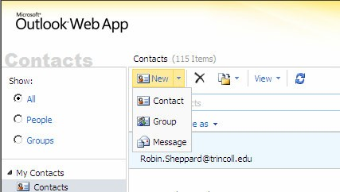Creating a Group Distribution List using MS Outlook Web App
Save time by creating an address with multiple email addresses!

1. Select CONTACTS from the options in the bottom left hand corner of OUTLOOK.

2. Once in CONTACTS, select the drop down arrow next to the word NEW.

3. Select GROUP.

4. A new window will appear. Type in
the GROUP NAME you wish to create
(i.e. 5th grade teachers).

5. Type in the name of a Rittman staff member or email address of the person you wish to add to the group in the MEMBERS line. One name per line. After each name, select ADD TO GROUP (or ENTER) to add the person to the group. Once the group list has been entered, select SAVE AND CLOSE.

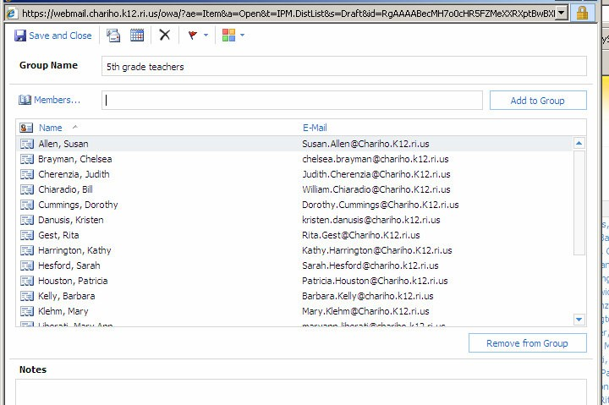6. To remove a member from a group, select the name and click on
REMOVE FROM GROUP.

To create an email to this group:
  - Click on Mail on the left side of the Outlook Web App window and click on New at the top
  - In the To... field, enter the name that you gave the group.

